Front: <https://github.com/natthakhon/FrontEnd>

Back: <https://github.com/natthakhon/BackEnd>

Technologies used

1. EF
2. SQL server
3. Web API
4. Angular

How to run the project?

1. In Demo.Back sln, modify the connection string at Demo.API.web.config, change the server and db name as wish.
2. Make sure Demo.Back has Demo.API as a startup project then run the Back end project.

\*\*\* note: please build the solution before running the project. \*\*\*

1. Once the back is up and running, run the Front end project Demo.Front.

\*\*\* note: please build the solution before running the project. \*\*\*

1. Create new student

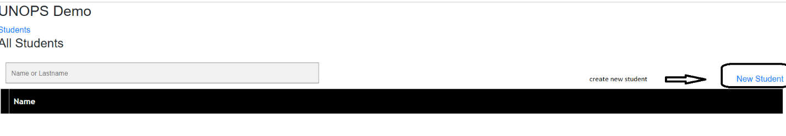

1. Put the name and last name then save

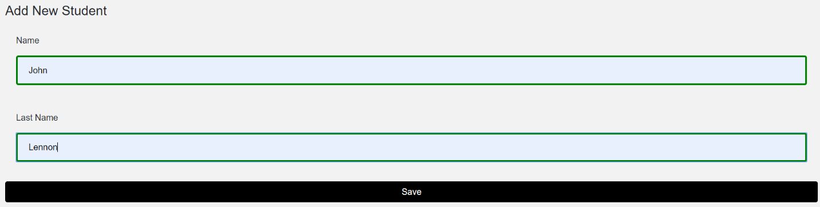

1. Back to student page

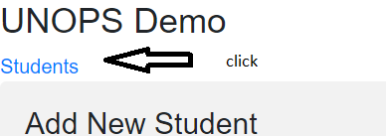

1. Check enrollment info by click the + sign in front of student name

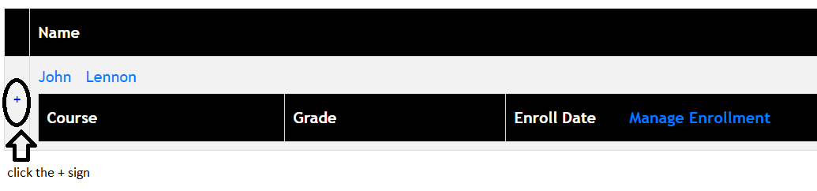

1. Click Manage Enrollment
2. Create new enrollment



1. Can create up to 4 courses click save when done

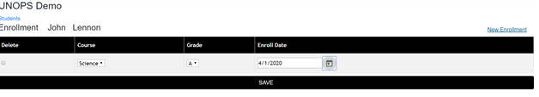

1. Click Students link to go back to Students page and click + sign to see newly created enrollment

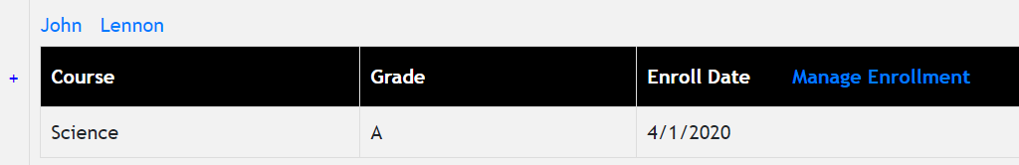

Notes:

1. Courses can be at maximum 4 courses (exclude the deleted one)
2. Be aware of changing the project front end port since it was hard coded for Cors in back end project.